Q. # write a program to store seven fruits in a list entered by the user.

b=[]

for x in range(0,7):

    a=input("enter the fruits name:")

    b.append(a)

print("the list is:")

print(b)

output:-

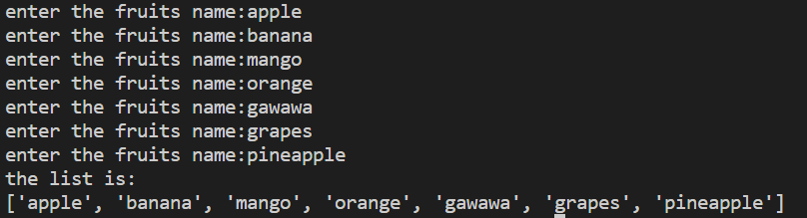

Q. # write a program to accept marks of 6 students and display them in a sorted manner

marks=[]

for x in range(0,6):

    print("enter the marks of",x+1,"th student:")

    a=input()

    marks.append(a)

list.sort(marks)

print(marks)

output:-

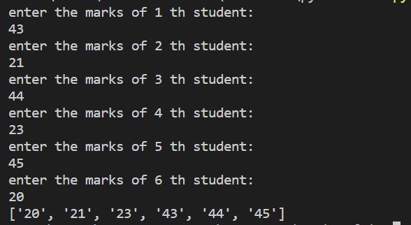

Q. #write a program to sum a list with 4 numbers

number=[]

sum=0

print("enter the numbers:")

for x in range(0,4):

    a=int(input())

    number.append(a)

    sum=sum+number[x]

print("the sum of",number,"is ",sum)

output:

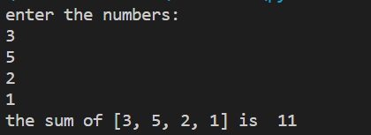

Q. #write a program to count the number of zeroes in the following tuple

a=(7,0,8,0,0,9)

b=a.count(0)

print("the number in the tupple ",a,"is",b)

output:-

